OSSP – PRACTICAL 6

Create a client-server application using Named Pipes (FIFOs). The client sends messages and the server processes and responds to them. Analyze FIFO behavior when multiple clients communicate simultaneously.
Create a POSIX signal handling program that captures SIGINT, SIGTERM, and SIGUSR1. Demonstrate asynchronous event handling and explain the role of signal handlers.

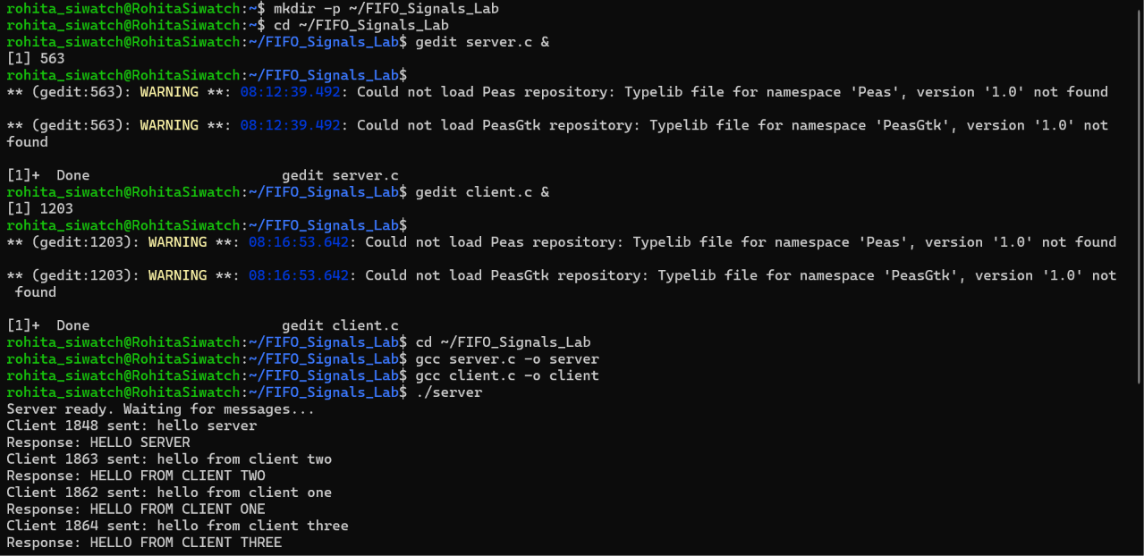
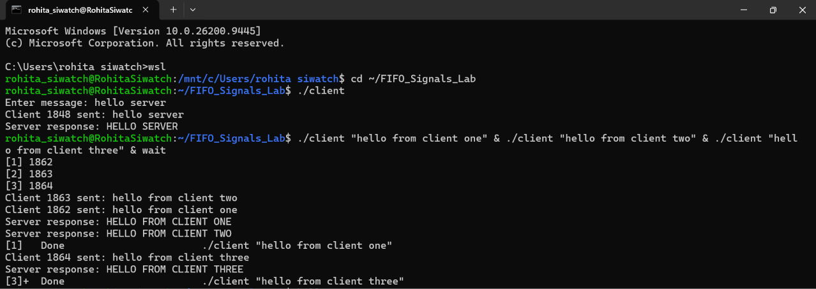
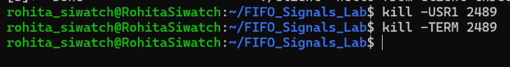
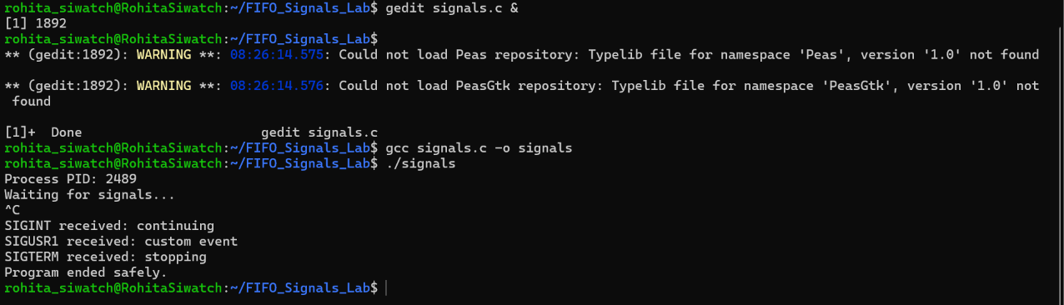

A signal handler is a function that tells a program what to do when a signal arrives. A signal can arrive at any time while the program is running. This is called asynchronous event handling.
SIGINT: Shows a message and keeps running.
SIGUSR1: Shows a custom message and keeps running.
SIGTERM: Shows a message and stops the program safely.

